**SAKTHI ARAVIND K   
Data Analyst & Data Scientist**

**REINFORCEDMENT PROJECT IN TABLEAU**

**ELECTRIC VEHICLE DATA ANALYSIS**

**Aim:**

This report aims to analyze the electric vehicle (EV) landscape, focusing on market growth, technological advancements, and adoption trends. By examining Battery Electric Vehicles (BEVs) and Plug-in Hybrid Electric Vehicles (PHEVs), the study provides insights into their market share, average electric range, and regional distribution.

**Scope:**

This report analyzes the growth and adoption of electric vehicles (EVs) from 2010 onwards, focusing on BEVs and PHEVs. It examines market trends, average electric range, and manufacturer dominance. Additionally, it explores state-wise distribution and CAFV eligibility to assess regional adoption patterns. Visualizations include line charts, bar charts, and pie charts for better insights.

**Objective:**

The objective of this report is to analyze the adoption and growth of electric vehicles (EVs), focusing on Battery Electric Vehicles (BEVs) and Plug-in Hybrid Electric Vehicles (PHEVs). It aims to:

1. Assess the total number of EVs and their growth trends from 2010 onwards.
2. Evaluate the average electric range to understand technological advancements.
3. Analyze the market share of BEVs and PHEVs, along with manufacturer and model dominance.
4. Examine the geographical distribution of EVs across states to identify high-adoption regions.
5. Determine the impact of Clean Alternative Fuel Vehicle (CAFV) eligibility on EV adoption.
6. Provide visual insights through charts and graphs for better understanding of market trends.

• **Total Vehicles:** 150,413

• **Average Electric Range:** 67.83 miles

• **Total BEV Vehicles:** 116,745 (77.62% of total EVs)

• **Total PHEV Vehicles:** 33,668 (22.38% of total EVs)



**Total Vehicles by Model Year:** Shows growth trends since 2011 till on January 2024.

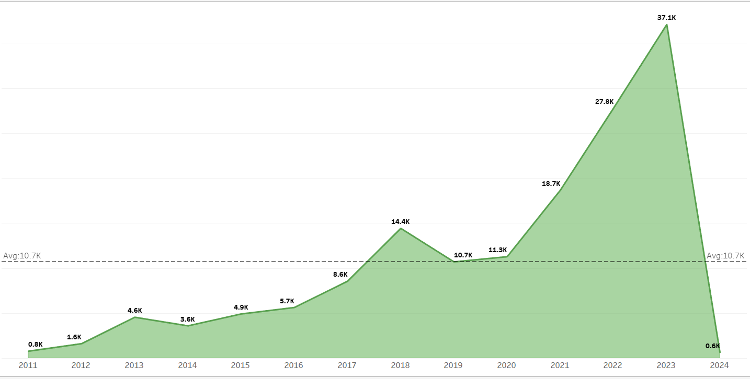

**Total Vehicles by State:** A map visualization was attempted but faced technical limitations and most of sales happened in WA.

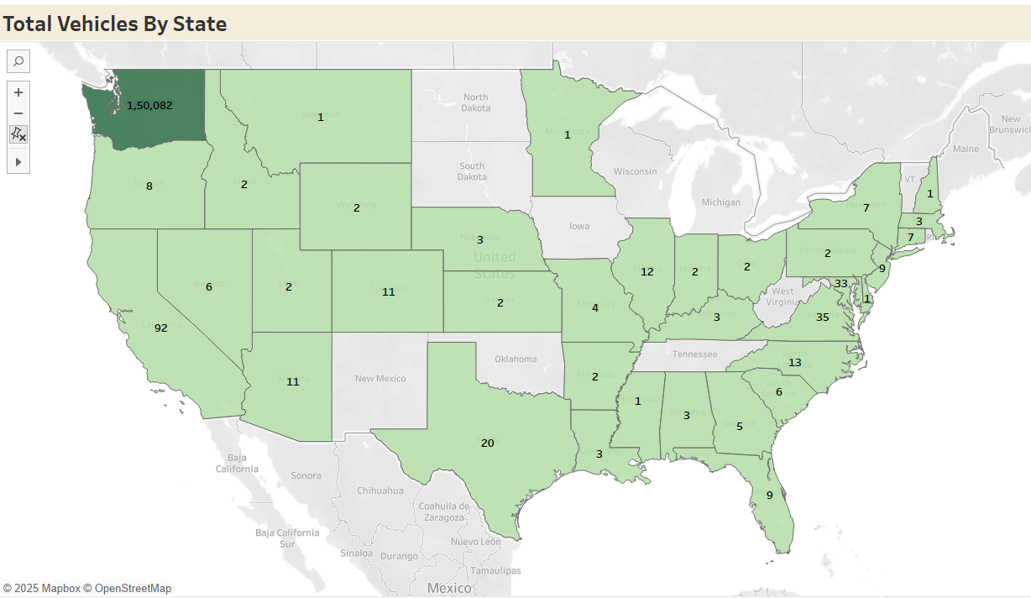

**Top 10 Electric Vehicle Manufacturers:** Tesla, Nissan, and Chevrolet are among the leaders.

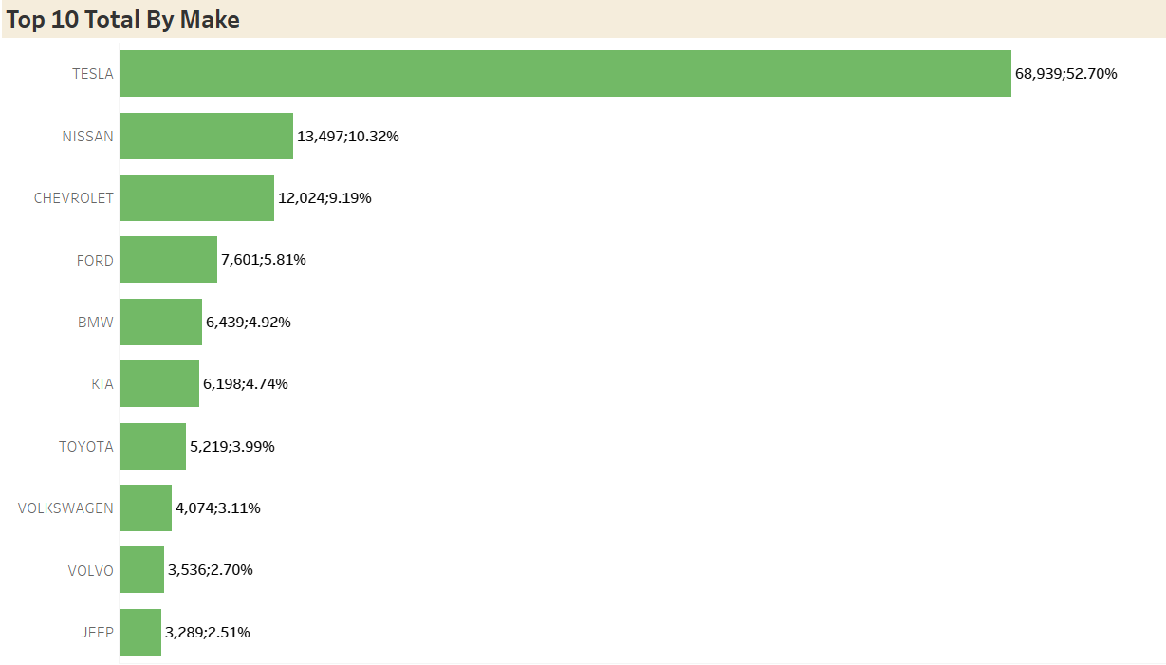

**Total Vehicles by CAFV Eligibility:** Displays eligibility distribution.

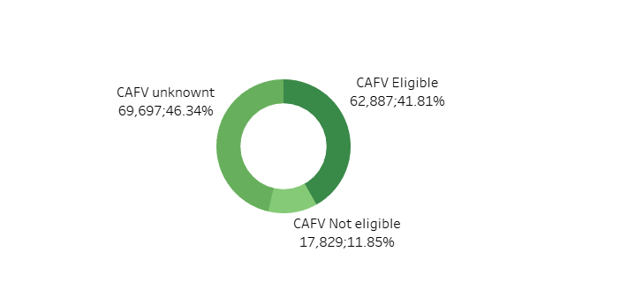  
**Top 10 Electric Vehicle Models:** Highlights the most popular EV models.

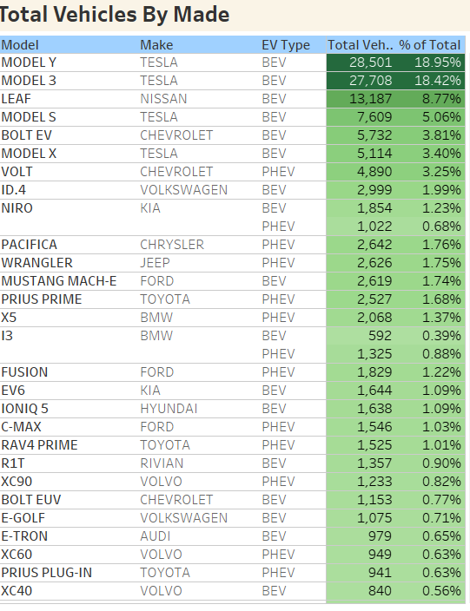

**DASHBORD**

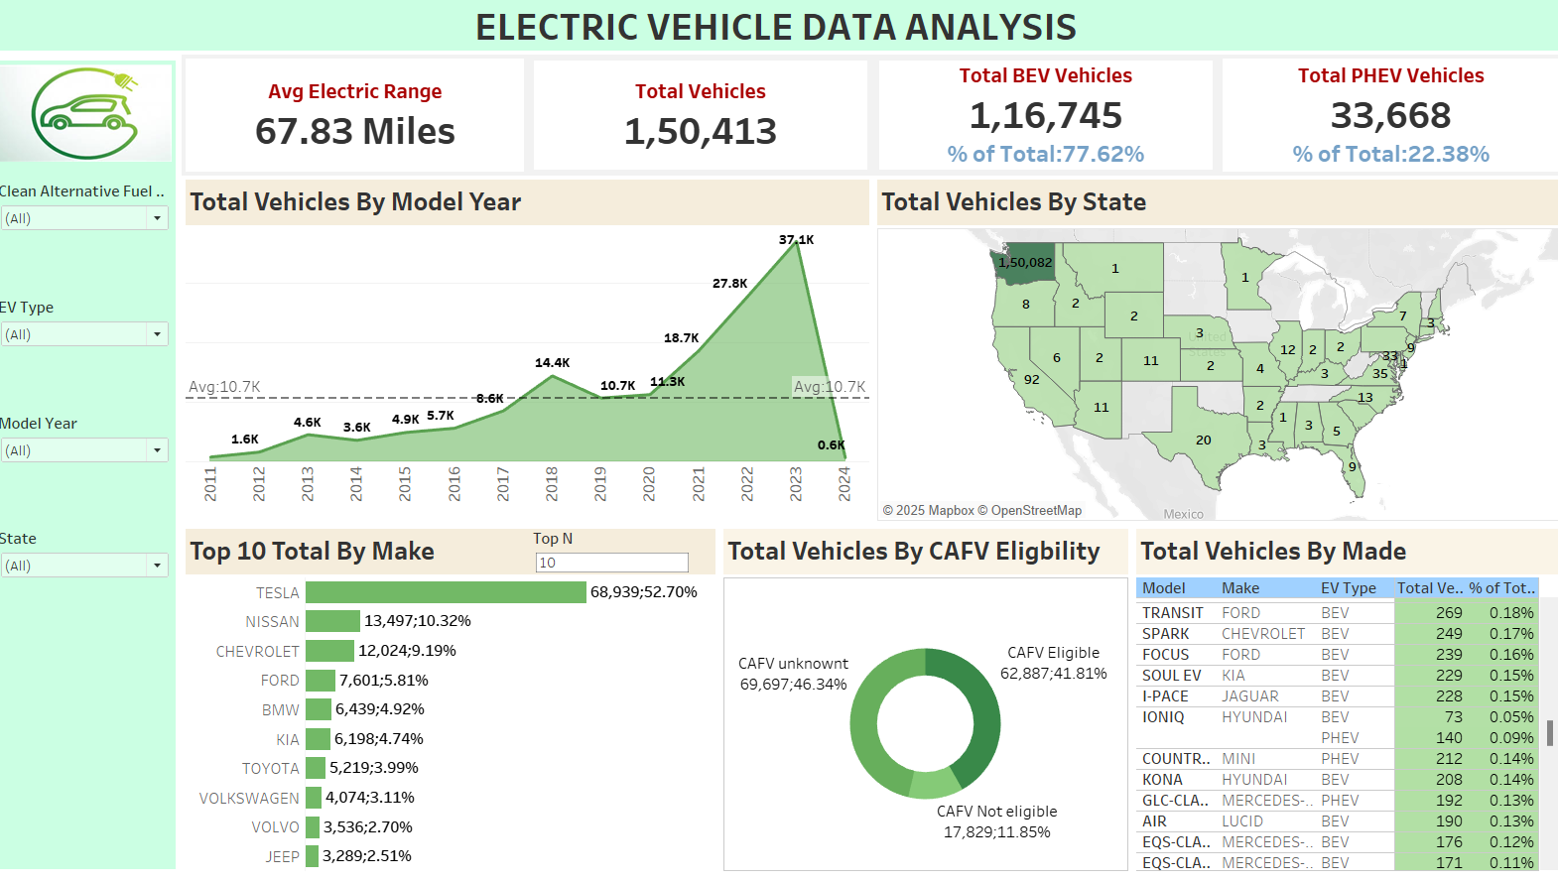

**Conclusion**

**Strong Growth in EV Adoption**

* The number of electric vehicles has increased significantly since 2011, indicating strong market growth and adoption of EV technology.
* The trend suggests a rising preference for sustainable transportation options.

**Battery Electric Vehicles (BEVs) Dominate the Market**

* BEVs make up 77.62% of the total EVs, showing a strong shift towards fully electric models.
* Plug-in Hybrid Electric Vehicles (PHEVs) account for 22.38%, indicating that hybrid technology still holds a significant share.

**Advancements in Battery Technology**

* The average electric range of 67.86 miles suggests steady improvements in battery capacity and efficiency.
* Newer BEV models show longer ranges, making them more viable for mainstream adoption.

**Geographical Concentration of EVs**

* Certain states show significantly higher adoption rates of EVs, influenced by government incentives, infrastructure, and environmental awareness.
* Policies such as Clean Alternative Fuel Vehicle (CAFV) incentives play a key role in promoting EV adoption.

**Tesla and Other Leading EV Manufacturers**

* Tesla, Nissan, and Chevrolet are among the top EV manufacturers, demonstrating strong brand dominance.
* The top 10 EV models include Tesla Model 3, Nissan Leaf, and Chevrolet Bolt, showing consumer preference for affordable and high-range EVs.

**Government Policies and Incentives Impact Adoption**

* A significant number of vehicles are CAFV-eligible, suggesting that government incentives strongly influence EV purchases.
* Policies that promote EV adoption, such as tax benefits and charging infrastructure development, have positively impacted the market.

**Future Growth Potential**

* With continuous battery improvements, increasing charging stations, and policy support, the EV market is expected to grow further.
* The transition to 100% electric transportation is becoming more viable, reducing dependency on fossil fuels.